**Task1:**

For a and b I have used standard validator tag as these could be simply done by using in built validators (like length limit and pattern regex)

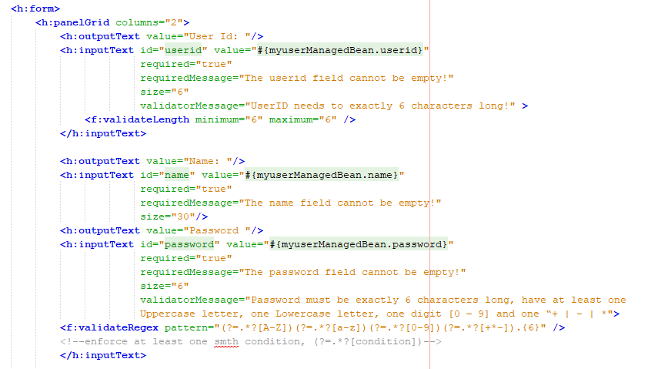

But for c, I had to use a user defined validation method in in the myusermanagedbean class. That’s because here we need to compare two strings and thus it is bestter to do this by coding it customly instead of relying on their inbuilt standard validation methods.

(note I have given reference to websites that have helped me just above the lines of codes )

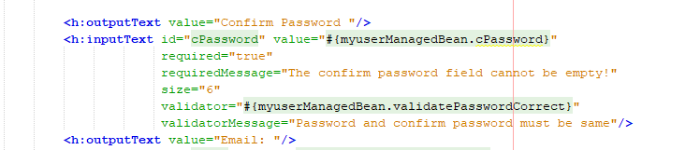

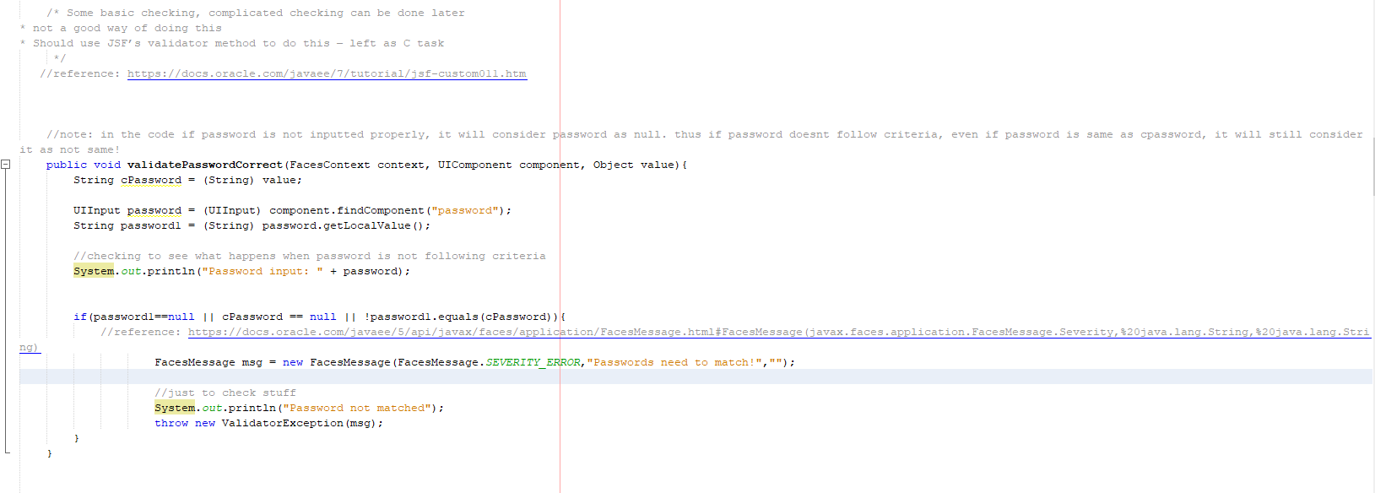

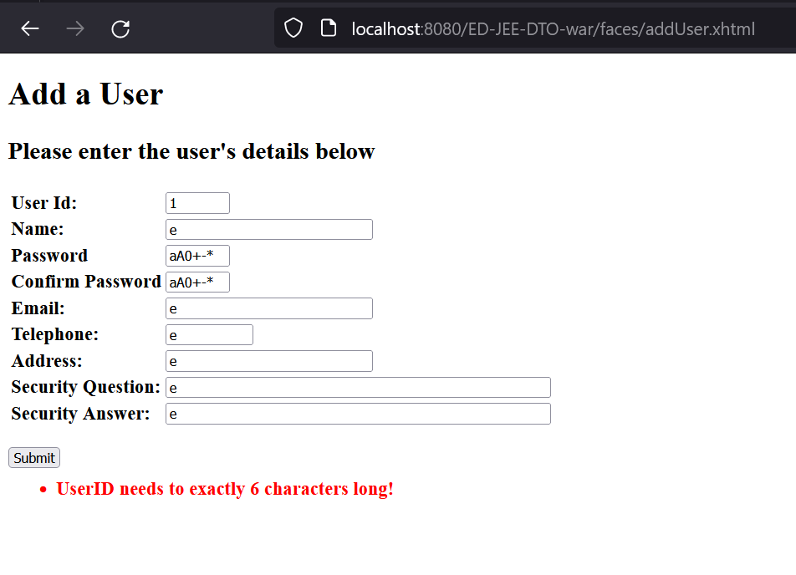Code outputs: 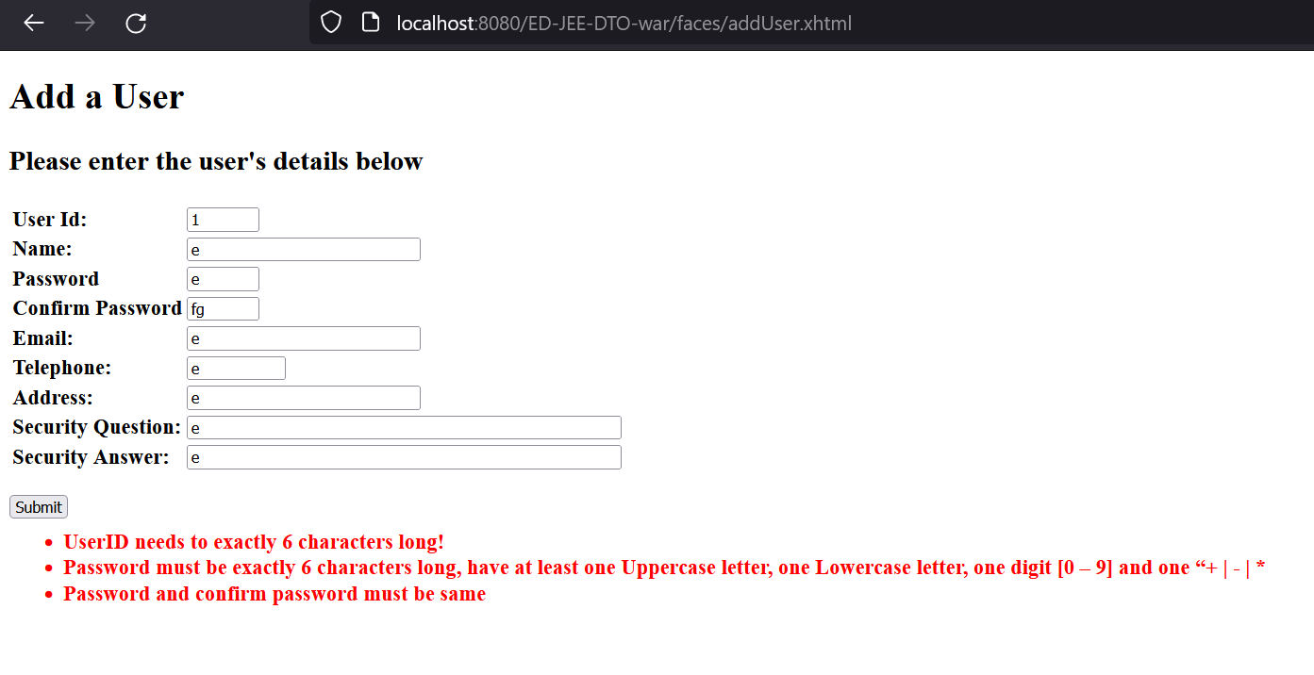

**Task4:**

During this process, I had suffered a lot trying to overcome the problem with the email. Honestly, this is probably the first time for me where I could instantly finish a C level task but still remain stuck on that week’s P level task. In brief, the functionality of the software (take 5.1P) in sending an email to my gmail for promting of successful edit/ update had not worked at all. Instead errors like SSL Hello error, etc kept popping up due to either lack/ corruption of jar file (this was the conclusion that had been obtained after troubleshooting it with the course’s tutors). Thus it was quite irritated to say the least.

But other than that, I did learn a lot in terms of how websites actually work and how to build up a smooth, efficient and scalable backend for the website itself. Furthermore, it has also allowed me to connect what I had learnt in my previous web application unit with OOP concepts, providing me access with a brand new and easier way to create a robust website (ie client tier, web tier, business tier, EIS tier and all other components and how they are linked)

Although I really liked the way hints were provided to help us search for and locate the two different ways of applying validation to forms, it did remind me of css and other aspects that websites normally have, which this website currently lacks completely. Thus, it made me feel a bit anxious thinking about all the different “internal server errors“ that I would have to face to add those parts , in order to make the websites presentation look more attractive (while ensuring those strange errors don’t pop up while trying to deploy or run it!)

In conclusion, although I have learnt lot of new things over these 5 weeks, I still have a long way to go and so I am currently looking forward to reaching that stage both with anticipation and worry.